|  |  |
| --- | --- |
| **AESOP4Food Living Labs and Research Questions**  **spring 2023** |  |

Contents

[Montpellier « L’agriparc des Bouisses » Living Lab /France 2](#_Toc127347664)

[Warsaw “MOST Urban Farm” Living Lab/Poland 4](#_Toc127347665)

[Ghent AGROECOLOGICAL URBANISM FUTURE HERITAGE Living Lab/ Belgium 6](#_Toc127347666)

[Madrid Agroecologico Living Lab/ Spain 8](#_Toc127347667)

[Bucharest “Buruiană Community garden” Living Lab/Romania 9](#_Toc127347668)

## [Montpellier « L’agriparc des Bouisses » Living Lab /France](https://drive.google.com/file/d/1FoZXktjnvHe_V9u3Tq-_9HVRAHjWRhq3/view?usp=share_link)

*Periurban agricultural park*

*Indicated for French speaking students (as many actors or resources around this project only speak French or are only published in French).*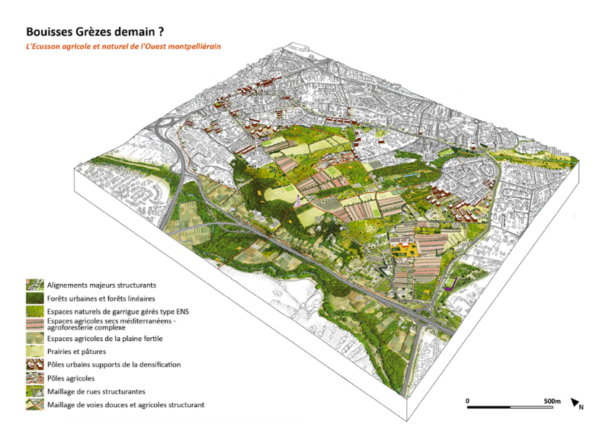

An agriparc is an agricultural park included in the urban space, combining different functions around agriculture. It is a landscaped place of production, marketing in short circuit, a refuge for fauna and flora, but also a place of green leisure open to all. Subjected to intense urbanization and heavy automobile traffic, the inhabitants of the western sector of Montpellier have suffered a degradation of their quality of life and their environment. With the Agriparc des Bouisses project, the ambition is both to create a new place of attraction for the entire sector, and to offer the inhabitants a quality landscape and natural area.

An innovative participatory approach has been launched with the inhabitants so that they can contribute to the agriparc project (on which the teams of landscape designers, urban planners and urban agriculture specialists will work).

**Assignment questions for local students:**

1. **Governance/public consultation**

* What lessons can be learned from the public consultation process?
* What recommendations to make for the next process?
* How to ensure that the public's opinions are taken into account during the project?

**2. Management of the agriparc**

* How to connect this agriparc to the city, ensuring that it is inclusive of all populations?
* How to reconcile leisure, recreational, environmental/biodiversity preservation, commercial and productive activities?

**3. Connections**

* How to make this agriparc an urban-rural connection point?
* How to relate this agriparc to a network of various agriparcs on the territory of the metropolitan area? Around which type of activities?

**Assignment questions for remote students:**

1. How to reconcile leisure, recreational, environmental/biodiversity preservation, commercial and productive activities?
2. How to make this agriparc an urban-rural connection point?

*(Answering those two questions with inputs from other experiences elsewhere - that you know, by inquiring on local case studies, or by literature)*

1. Building a typology of urban agriparcs, based on literature.

## [Warsaw “MOST Urban Farm” Living Lab/Poland](https://docs.google.com/presentation/d/1m7p8yf3m6NTqWwhltN8dITUo6Xvvd1_b8l-Xyfz8zYA/edit" \l "slide=id.g1897f58c12d_0_0)

*Production and collaboration with local farmers*

[*Short video presentation*](https://drive.google.com/file/d/1FZvY1t1ptUOfIXTSJ8XrFWJecCt6WlrU/view?usp=share_link), [*Short pdf description*](https://drive.google.com/file/d/17ktvoyrsGXGEFoLZa-rMJO8s6X28QBgi/view?usp=share_link)[2023-01\_MOST\_LL\_en](https://docs.google.com/presentation/d/1m7p8yf3m6NTqWwhltN8dITUo6Xvvd1_b8l-Xyfz8zYA/edit?usp=sharing)*,* [*Extended description*](https://drive.google.com/file/d/16pt-fedVoeDlRy5I5Mki1kRvg6OCDaBU/view?usp=share_link)

[*https://drive.google.com/file/d/1FZvY1t1ptUOfIXTSJ8XrFWJecCt6WlrU/view?usp=sharing*](https://drive.google.com/file/d/1FZvY1t1ptUOfIXTSJ8XrFWJecCt6WlrU/view?usp=sharing)

The Warsaw Urban Farm initiative was born out of the need to prepare the city for the upcoming effects of the environmental and food crises. Our goal is to create a local center for agro-ecological education and food production, and to develop and network future leaders in the field of sustainable food planning to contribute locally to food security and a healthier environment.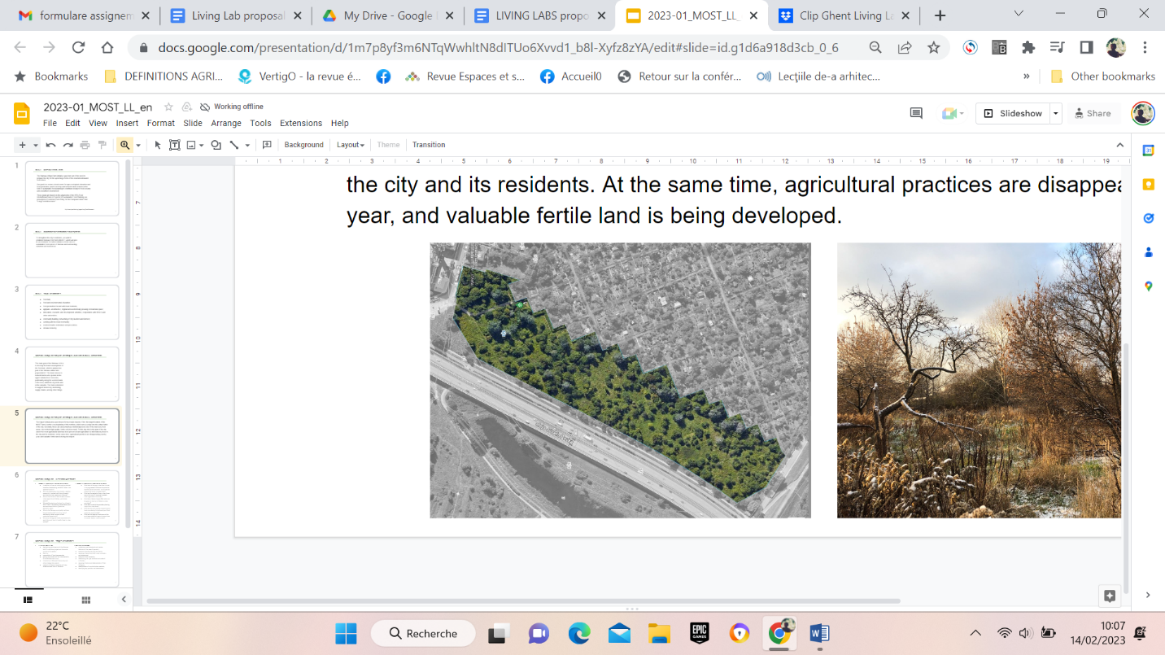

To strengthen the city's resilience, we want to establish Warsaw's first farm (MOST), which will also be an incubator for further initiatives in the area of sustainable food system of Warsaw and surrounding suburban and rural areas.

**Assignment questions for the local students:**

1. In addition to financial, what are the potential benefits of establishing the MOST farm in the selected location?

(methods: literature review on relevant examples of urban farms and food hubs in other cities; analysis of spatial planning documents; field trip; spatial analysis; identifying key partners and stakeholders; identifying main problems and challenges faced by farmers operating in the selected area; SWOT analysis for the Warsaw agriculture of the upper Vistula)

1. What should be an economic model of the MOST farm?

(methods: literature review on relevant examples of urban farms and food hubs in other cities; academic papers review; field trip; identifying main problems and challenges faced by farmers operating in the selected area; SWOT analysis for the Warsaw agriculture of the upper Vistula, developing an economic model )

1. Who are stakeholders (municipality, neighbor community, involved institutions, and farmers) and what are their needs and influence?

(methods: field trip; analysis of land ownership; identifying key partners and stakeholders; mapping all actors and their needs and power; define potential partnerships and alliances)

1. What is the attitude of local farmers towards urban agriculture initiatives, particularly MOST?

(methods: field trip; mapping local farmers; interviews and questionnaires; designing a food hub)

1. What edible plants are the best to cultivate in MOST farm? Considering climate factors and socio-economic factors (production feasibility, retail).

(methods: literature review; field trip; consultation with an expert)

1. What is the Warsaw municipality's attitude toward biodiversity? Is it only a cost of maintaining vacant lands or a food production opportunity?

(methods: analysis of Municipality planning documents; interviews and questionnaires)

1. What are the regional rituals associated with agriculture and how to transfer them to urban context?

(methods: literature review; field trip; mapping local farmers; interviews and questionnaires; developing a proposal for an urban harvest celebration)

**Assignment questions for the remote students:**

1. What should the coop urban farm include in its programme? What are the potential benefits (social, economic, environmental, others) and how to increase them?

(methods: literature review on relevant examples of urban farms and food hubs in other cities; academic papers review; field trips)

1. What are the models of coop urban farms around the world? (Economic models, inner organization structures).

(methods: literature review on relevant examples of urban farms and food hubs in other cities; academic papers review; field trips)

1. What are the city's policies towards vacant lands considering its biodiversity and food production opportunities?

(methods: literature review on relevant examples of urban farms and food hubs in other cities; academic papers review; analysis of Municipality planning documents; interviews and questionnaires)

## [Ghent AGROECOLOGICAL URBANISM FUTURE HERITAGE Living Lab/ Belgium](https://drive.google.com/file/d/1Z_VdtJMcqawjgcNDbJwV5pUVH1igqHxU/view?usp=share_link)

***Leveraging publicly owned farmland for an agroecological transition in the peri-urban fringe of Ghent***

[*Short video presentation*](https://drive.google.com/file/d/14iv1wI_dyPHb-8c-PXdksOc8FKrXM5lo/view?usp=share_link), [*Short pdf description*](https://drive.google.com/file/d/1Z_VdtJMcqawjgcNDbJwV5pUVH1igqHxU/view?usp=share_link), [*Extended description*](https://drive.google.com/file/d/1C0JqsrZYeHwLDzu5cKEfkWjwn6-vXP8Q/view?usp=share_link)

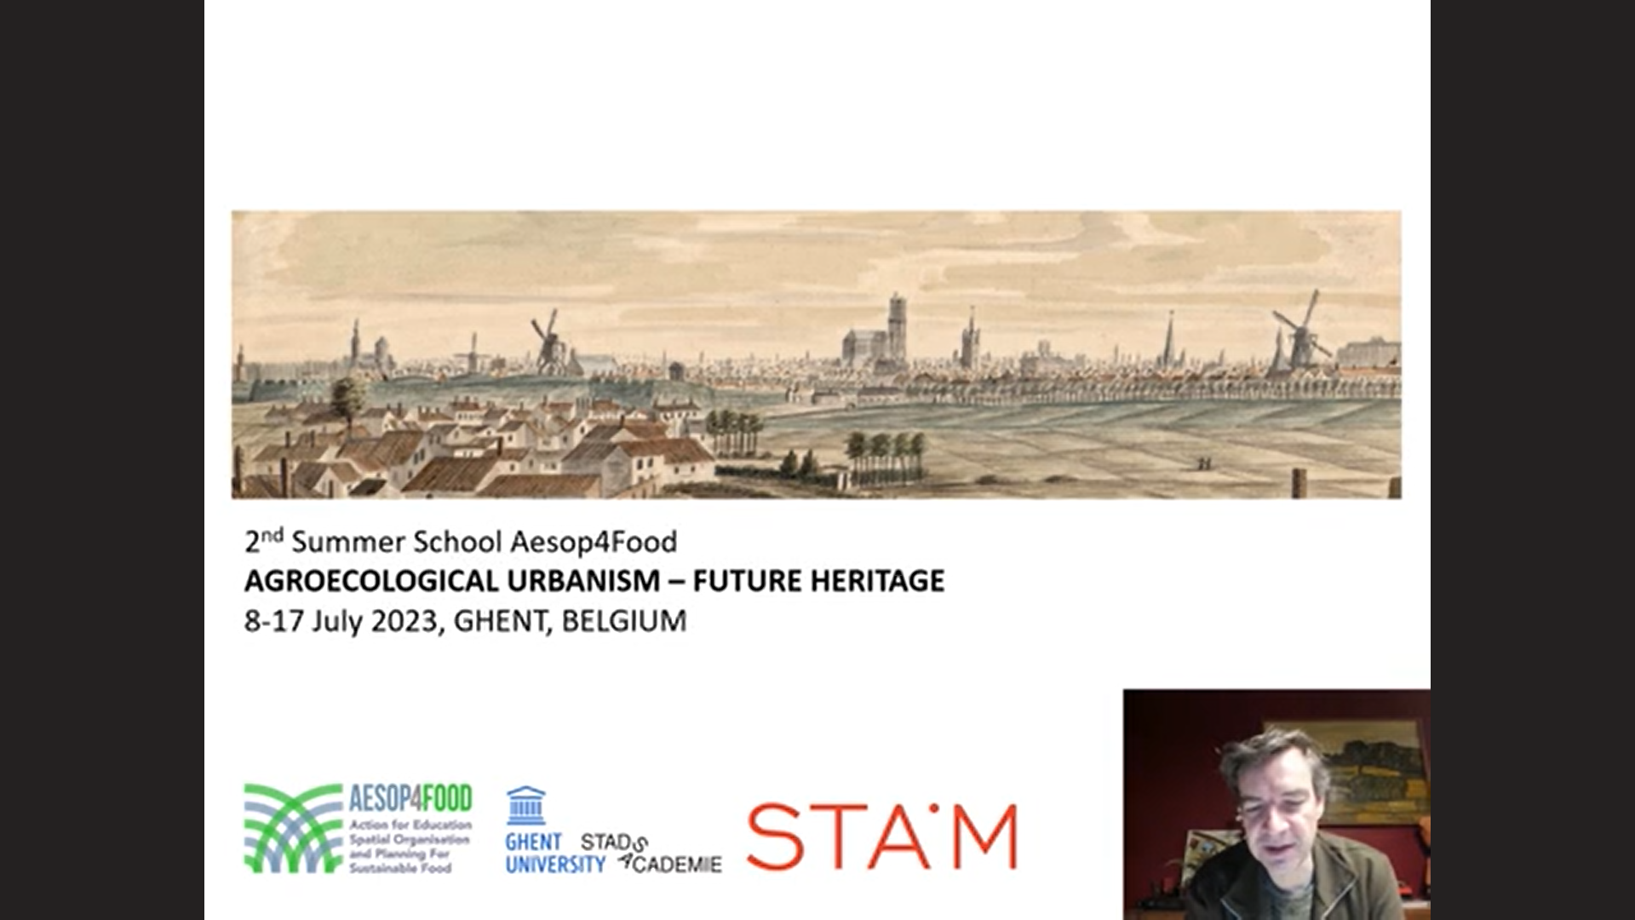

The urban food policy of the City of Ghent, Gent en Garde, has been the subject of international attention including several prestigious prizes. At the same time the systematic sale of public farmland in the peri urban fringe of Ghent has alienated new and traditional farmers who are upset about the systematic loss of farmland. Farmers are rapidly disappearing from the peri urban fringe, and new farmers face great difficulty to establish themselves.

Within De Stadsacademie we want to enter in a dialogue with parties that could help to articulate a shared agenda regarding the way in which the public ownership of farmland could be leveraged to accelerate an agroecological food transition.

**Assignment questions for remote students:**

1. **Literature review on public land management for an Agroecological Urbanism.**

* What are the main areas of connection between municipal food policies and public farmland management?
* What are the key challenges or obstacles to integrate public farmland management within urban food policy?
* What are the key points of connection or areas of policy making that have been identified by local or regional authorities to forge a better connection between farm land management and food system transition objectives?

1. **Documentation, discussion of existing practices connecting food policy and public land management**

* Examples of projects, plans or initiatives operating within the intersection between strategies of environmental land management (in light of nature conservation, green blue infrastructure, water management, etc) and food policy initiatives. We are particularly interested in strategies focussed on the harvesting of drinking water in farming areas (i.e. initiatives by ‘eau de Paris’).
* Examples around public catering within public institutes (schools, hospitals, care facilities…) that make a direct connection between public food provisioning, agroecological farmers and land management.
* Examples of neighborhood based initiatives around food support and place based solidarity in connection with agroecological farmers. We are particularly interested in community kitchen initiatives building a food sovereignty agenda together with agroecological producers.
* Examples of investment in land readjustment and development of (new) collective farmers operating infrastructure in light of an agroecological transition and the activation of peri urban farmland. We are particularly interested in initiatives working on nutrient cycling, biomass harvesting in light of composting and soil remediation initiatives (on and off farm).

## [Madrid Agroecologico Living Lab/ Spain](https://drive.google.com/file/d/1tRL52MzGKMEH_Roa-peYZgD6S7NRFmCy/view)

*Short video presentation,* [*Extended description*](https://drive.google.com/file/d/1tRL52MzGKMEH_Roa-peYZgD6S7NRFmCy/view?usp=share_link)

The Living Lab is conceived as a space of interaction with the platform Madrid Agroecologico, to provide support to make progress in one of their current main goals: consolidate the precarious network of agroecological farmers in the peri-urban area. . In the last assembly, Madrid Agroecológico identified the need to optimize food fluxes (and transport) to improve the feasibility of farmers.It was set as a priority action for 2023 and request for support to draw a detailed análisis of food flows and an ecobalance to re-define distribution and logistic processes. 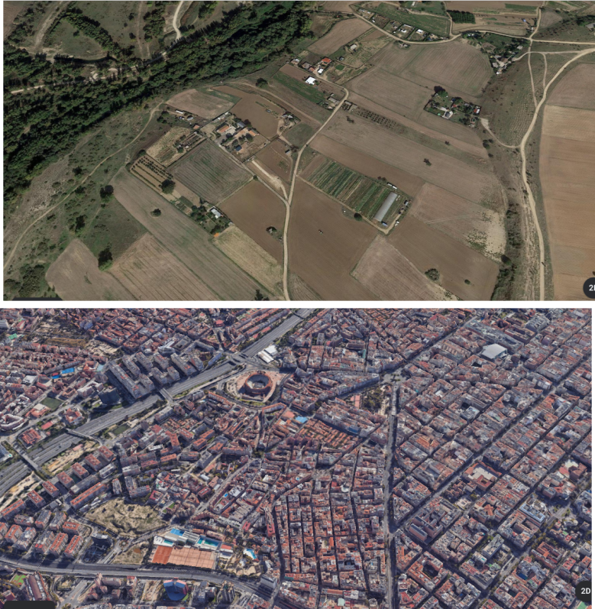

A second goal of the LL is to check the possibilities to adapt the concept of "agroecological biodistrict" to one of Madrid’s districts and an associated region, revisiting current nodes of production and consumption in order to expand.

**Assignment questions for remote students:**

1. What can be learned from agri-food cluster development to be applied to small scale and scattered agroecological farms?
2. Examples and good practices on food hubs or collective facilities adapted to small scale farmers
3. Examples and good practices to upscale agroecology from the farm to the landscape. Are alternative food networks and agroecological farmers recognisable in the landscape? and in the urban scene?
4. Comparison of an alternative food network with the “standard” food chain, in which ways do the AFN have better performance?
5. Which planning tools can be activated to address the needs of small agroecological farmers ?

## [Bucharest “Buruiană Community garden” Living Lab/Romania](https://drive.google.com/file/d/1Jy3NHQVhfSJ3U2JORusZPIhExp9txgzg/view?usp=share_link)

*A community garden in the peri-urban area of Bucharest.*

[*Short video presentation*](https://drive.google.com/file/d/1af6hu6RirC2WbKl5h9cWtABJLhNqN4F6/view?usp=share_link), [*Short pdf description*](https://drive.google.com/file/d/1Jy3NHQVhfSJ3U2JORusZPIhExp9txgzg/view?usp=share_link)*,* [*Extended description*](https://drive.google.com/file/d/1RqfiEz3gn2Uht0Ud05X4qwahFQaB6xOL/view?usp=share_link)

The *Buruiană* community garden is a bottom-up initiative of a group of young people who want to lead a sustainable lifestyle. It was funded in 2021 and the aim is to host a space for growing food, education and socialisation following principles of regenerative agriculture and sustainable practices. Members have access to the community garden and/or allotment gardens inside the 9000 sqm plot, located next to a river and accessible by car. 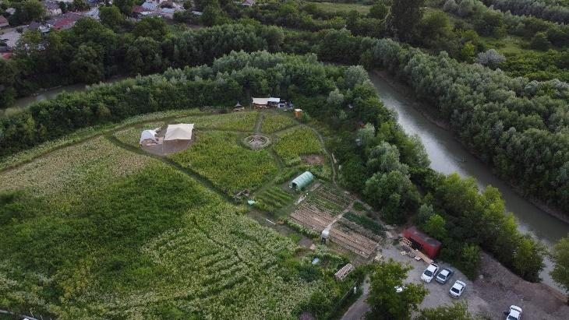

*Fig.  . Aerial view of Buruiană garden. Source:* [*https://www.facebook.com/gradinaburuiana*](https://www.facebook.com/gradinaburuiana)

**Assignment questions for local students:**

1. **Concerning the general topic:**

* What are good practice models for community gardens in the peri-urban area of a big city in the context of city inhabitants starting to learn about the existence and benefits of urban agriculture, and locals still practising agriculture in an individual and specific traditional manner?
* Can urban agriculture be considered a leisure or educational activity for city inhabitants?
* Is the eastern european and post-socialist context appropriate for the development of urban agriculture in the form of community gardens?
* Can urban agriculture and community gardens encourage people to lead a more healthy and sustainable lifestyle?
* What laws and regulations can encourage the development of urban agriculture and community gardens?

1. **Addressing the interest of local people:**

* Can community gardens be attractive for locals who mostly practise agriculture in their own private gardens? Can community gardens function as a space where exchange of knowledge between generations can take place, learning both from traditional local practices in the peri-urban areas and from innovative gardening techniques like permaculture? Can permaculture revive older traditional practices?
* Can community gardens address unemployment and provide training for employment in agriculture?

1. **Addressing the challenges of the community garden:**

* What financial model is most suitable and ethically appropriate for funding community gardens in a sustainable, inclusive way?
* Can vulnerable categories like elderly, children and people with disabilities be integrated in activities and projects in the community garden? What are those activities? Is there a possibility of obtaining funding for these activities?
* What events and activities can be hosted to attract participants, new members and locals?

**Assignment questions for remote students:**

1. **What are good practice models for community gardens** in the peri-urban area of a big city in the context of city inhabitants starting to learn about the existence and benefits of urban agriculture, and locals still practising agriculture in an individual and specific traditional manner?
2. **Good case-study examples of events and activities can be hosted to attract participants**, new members and locals.
3. **How to address the Eastern European and post-socialist context** in an appropriate manner in order to support the development of urban agriculture in the form of community gardens?
4. **What financial model** is most suitable and ethically appropriate for funding community gardens in a sustainable, inclusive way?
5. **A literature review of laws and regulations** that can encourage the development of urban agriculture and community gardens.