# Student: Juan Cruz Demicheli

# Document: 38.795.473

# Living lab: Madrid

# Tutor: Marián Simón Rojo

# Focus/scope of the research

The scope of the research shifted during the process of the course to improve the link (and usefulness) between the assignment questions and the development of the LL research. There were several reasons that influenced that shift: i) the progressive and deeper understanding of the reality of the LL (field of play), it´s regional setting and contemporary challenges; ii) the collective approach of the group which allow the different cultural perspectives and professional expertise to foster a sense of community and joint vision -and objective- to actually contribute to the development of knowledge in the LL and the people “behind the scenes”.

That is how during my first presentation, my assignment question was: “the comparison of an alternative food network with the standard food chain, in which ways do the AFN have better performance?”. That research operated in a very theorical level and focused on identifying those “comparative dimensions” such as: environmental, social, economic and networking; to quantify or describe “strengths” and “weaknesses”

However, due to the collective learning process, my second presentation change its question to “How is the current AFN of our LL organized? Which stakeholders are involved? How is the logistic dimension functioning? How do Buenos Aires AFN universe relates to MADRID´s?, Are there ”Argentinian” SFSC schemes that are not being used in Madrid? Can they be adapted?

In this sense, the aim of the research is a pragmatic one, thus facilitating the collaboration with the LL. We will focus on mapping the LL -and comparing (to some extent) to what we find in Buenos Aires- using different methods to incorporate other insights to reflect on the understanding of sustainable food planning within the Madrid food system.

# Context of research aim

Regarding the context of the research we will be dealing with two different scenarios. The Buenos Aires and “Madrid” universe. Although separated by thousands of kilometres and an ocean, this cities and societies do share historical bonds, a common language and register historical relationships between iberoamerican researchers. Furthermore, regarding the “field of play”, we do find several similarities between cities (population and urbanization rates)

In Buenos Aires, the key general “food issues” are: the rise of food prices[1] (21,8% during April for vegetables and 10,4% for dairy products[2]) and the low consumption of fruits and vegetables of our population. Dealing with the AFN universe, those experiences had accomplished a remarkable growth during the pandemic[3] but since 2022 are slowing down it´s growth and are actually struggling to sustain their operatory (Urcola, 2020; Demicheli, 2022). Buenos Aires is a signatory city of the MUFPP. Furthermore, we are in the midst of an electoral year that has no precedents and it´s impacting us all in multiple ways.

At the other side of the puddle (the Atlantic Ocean), Madrid city and 6 other municipalities within the “comunidad autónoma” are also signatory cities of the MUFPP, showing a regional concern for food planning. Nonetheless, they are also experiencing a decrease in vegetable and fruit consumption[4]. Regarding the AFN universe, there are some concernings regarding the progressive disappearance since 2018 of AFN experiences with more than 7 years of life and the closure of a logistic AFN experience/food hub called “Madrid KM0” which was expected to solve many of the logistic problems of the agroecological farmers of Madrid. Apart from that, the AFN scheme that seems to function around the city are the “grupos de consumo”. Besides, Madrid also has one AFN scheme that Buenos Aires does not, the cooperative supermarket(although one has recently closed, SuperCop).

# Research approach and method

The research approach was a “relational study” between two case studies: Madrid´s Living Lab and Buenos Aires AFN universe.

This method was complemented by one virtual interview with the “leader” of the “Unión de Huertas” of Madrid, plus a dense literary review sustained by professional experiences.

# Main findings /case study and discussion

To begin with, the interview conducted to Daniel from “Unión de Huertas” allowed us to analyse the local foodscape and it´s complexity. First of all we were presented with the general description of the “Unión de Huertas” and it´s farmers. At the moment the UH is integrated by 4 farmers but it will probably add one more member in the coming months. They are all agroecological farmers who work under 1ha of land and they are distributed in an uneven way all over the Madrid region. The logistic and commercial problems they faced individually -besides political and ideological reasons- pushed them to come together and forma an organization. Their objective is to *“supply food to cooperative supermarkets or agroecological distributors*” or public institutions. They have one private client and that situation is “troubling” for them, despite the fact that they need that commercial relationship

Anyway, we found out that the farmers of the UH sustain two food supply chains. An individual one where each farmer relates individually with a specific group of consumers and the collective way where they sell cooperatively. Each of these schemes implicate commercialization and logistics differences which are explained in the following table.

**Table 1 – Commercialization and logistics dimensions of the collective and individual food chains**

|  |  |  |
| --- | --- | --- |
|  | **Commercialization** | **Logistics** |
| Individual way | * Each Farmer sustains “grupos de consumo” * 5kg of mix vegetables boxes | * Organized individually * Particular vehicles * Distribution on Mondays/Tuesdays |
| Collective way | * Farmers sell collectively to cooperative supermarket, etc. * Bulks of different sizes * 35 bulks per month * 6-7 regular clients | * Organized by “cooperative” representative (paid): routing, supply distribution, etc. * Van to van gather and distribution of vegetables in centre and downtown Madrid * Distribution on Tuesdays |

To map this scenario, we present the Map 1. This map, besides showing the locations of the principal stakeholders (farmers and consumers), shows the different flows of food that implicate each food chain, visibilizing that the collective ones are fewer but larger. As the map shows, the reduced numbers of regular clients is a problem that if solved (UH affirms that is has many potential clients) would enhance the other existing problem: logistics and dispersion. At that point is where the objective of scaling up/out and reducing the cost of transportation appear. Maybe the concretion of one objective helps to solve the other one?

On the other hand, Map 2 shows the potential new flows that would appear if the Project of “building” a “stock/logistic common space” succeeded as well as the goal of convincing UH members to sell collectively all of what each farmer harvests.

**Figure 1 – Actual food chains and flows Figure 2 – Potential food chains and flows**

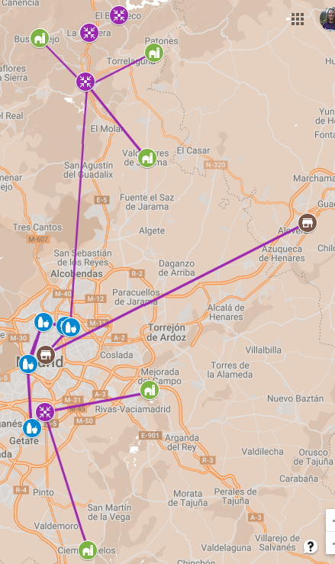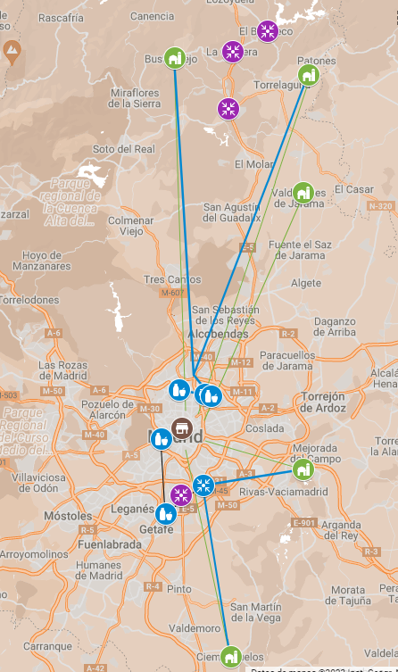

Source: Own elaboration

**Table 2 – References of Map 1 & 2**

|  |  |
| --- | --- |
| **Map reference** | **Actor** |
|  | Farm and farmers |
|  | Cooperative supermarket |
|  | “Conventional” client |
|  | Potential “conventional” client |
|  | Potential “distribution and logistics centre” |
|  | Actual “distribution and logistics centre” |
|  | Potential flow of food |
|  | Individual flow of food commercialization |
|  | Collective flow of food commercialization |

Source: own elaboration

To complement these figures, we estimated the kilometres that require each scenario. The results are presented in the table 3

**Table 3 – Approximate kilometres demanded by each flow**

|  |  |  |  |  |  |  |
| --- | --- | --- | --- | --- | --- | --- |
| Flows | Figure 1 total Km | Fuel expenses[5] | Time and labor cost | Figure 2 total Km | Fuel expenses[6] | Time and labor cost |
| Individual Flow | 161 km. | 11,27 € | X | 73 km. | 5,11 € | X/2 |
| Collective Flow | 140 km. | 9,8 € | Y | 57 km. | 3,99 € | Y/3 |
| TOTAL | 301 km. | 21 € | X+Y | 130 km. | 9,1 € | (X/2)+(Y/3) |

Source: own elaboration

Apart from these representations, what matter the most in terms of actually comprehending a foodscape, is the nature of the actors involved, their roles and tasks. That is why we use two models to map what literature calls Short Food Supply Chain typologies and the functions within. The one proposed by Jarsebowski et al (2020) and the UNIDO model (2020). Besides, is at this stage when we begin to show SFSC models of our other case study of Buenos Aires.

By doing this exercise (figure 3 and 4) and complementing with some of the insights acquired in my professional experience, we gather the following findings:

* Madrid´s LL incorporates schemes that involve a high compromise of real consumers while in the Buenos Aires´s universe, what we call "consumers" are actually commercial organizations framed in the concept of “solidarity intermediation”. This difference of citizen participation implies that collective action planning within multi stakeholders platforms that require participation are possible in Madrid´s case.
* According to Jarzebowski typology, Madrid´s LL does not have SFSC that imply high levels of compromises adopted by producers while in Buenos Aires there exists a farmer´s association called Unión de Trabajadores de la Tierra which coordinates several cooperative supermarkets in the city, a wholesale agroecological market and coordinated the (conventional) wholesale market.
* There are many schemes that are incorporated but there are others that are not. That scenario leaves some room for testing and innovating with those schemes.
* There is good balance between schemes that demand high levels of compromise for producers and those tan demand high levels of compromise for consumers.

**Figure 3 - Main actors of Madrid LL and SFSC typology (Jarzebowski et al, 2020)**

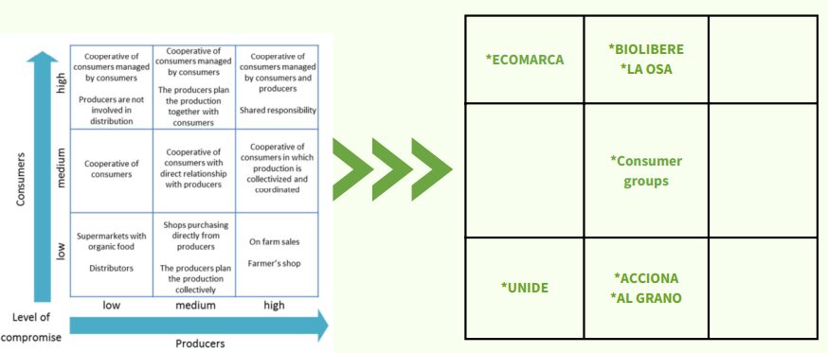

**Figure 4 - Main actors of Buenos Aires AFN universe and SFSC typology (Jarzebowski et al, 2020)**

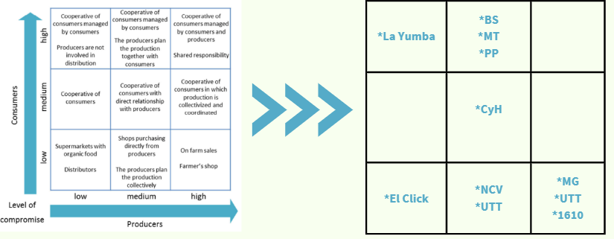

Source: own elaboration

Besides the nature and relationship between the stakeholders, there are determinants of “SFSCs effectiveness” that need to be accounted for. Logistics[7] are one of those key functions. In order to assess this, the following model allows us to identify the logistic activities involved in our cases and the way the functions are distributed.

**Figure 5 – Functions in agrifood chains**

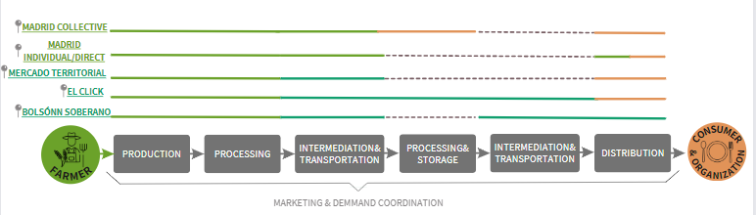

Source: own elaboration

Figure 5 shows clearly shows that Spaniards farmers are assuming more functions than their “porteños” counterparts. Particularly, they are always sustaining transportation activities and those require a lot of time and are highly costly.

In Buenos Aires we can find many different organizations (acting like food hubs) that specialize in logistics and commercialization (Universities, shops, etc). We could argue that this approach relates to the search for economies of scale. As a matter of fact, they usually face sustainability issues as they rely on voluntarism and symbolic wages. Nonetheless, these organizations are managing to commercialize thousands of boxes and bulks per week (of supposedly agroecological food).

# Conclusion

In conclusion, the research project contributed to gain some insight regarding the logistics, the stakeholders and the SFCS schemes that appear in the Madrid´s LL. Regarding the logistics and the possibly rearrangement of food flows, we learned that by organizing a food hub/logistic platform placed near the productive sites to group the products from each farm, we could reduce the kilometres made – and their consequently costs – significantly. In terms of the distribution of the functions, comparing Madrid to Buenos Aires, it appears that a reallocation of functions is needed to minimize the “efficiency losses due to de-specialization” and the high demand of work that the farmers have. Finally, even though we did not get into quantitative details of the commercialization, a scaling up is needed. To achieve it, trying to link with actors that would require low or medium compromise by the farmers (left side of figure 3), particularly in term of arranging logistics and transportation, would be suitable.

# Self reflection

The challenge of contributing to the process of a LL, being a remote student, was a complex but a really valuable one. Working from Argentina, having the possibility to get in touch with Hispanic realities related to food systems, facilitated my process and allowed me to comprehend and bond with the LL´s reality from a different perspective. However, I did have some issues trying to make sure that my work with the assignment question contributed to the objectives of the LL but by discussing it with my tutor and my teammates, I believe we surpass them.

Apart from that, the practical focus of the course and the LL methodology really pushed me to work hard to generate knowledge and implement tools that could contribute to Madrid´s farmer´s reality.

# Main references

Belletti, G., & Marescotti, A. (2020). Short food supply chains for promoting local food on local markets. United Nations industrial development organization.

Caracciolo Basco, M., Fontana, P., Haro, A. D., para la Cooperación Técnica, F. C., José, S., Competitividad, P. I., & de Cadenas Agrícolas, S. (2016). Situación de la institucionalidad de apoyo a la innovación comercial y de los procesos de gestión comercial de la agricultura familiar en la Argentina.

Craviotti, C., & Soleno Wilches, R. (2015). Circuitos cortos de comercialización agroalimentaria: un acercamiento desde la agricultura familiar diversificada en Argentina. Mundo agrario, 16(33), 00-00.

Demicheli, J.C. (2022). Análisis y desafíos de los circuitos cortos de comercialización en la transicion pospandémica.

Del Valle, J., Jiménez, L., Morán, N., Clemente, R., & Medina, Á. (2019). La producción agroecológica en la Comunidad de Madrid. Radiografía del presente y una mirada hacia el futuro.

Jarzębowski, S., Bourlakis, M., & Bezat-Jarzębowska, A. (2020). Short food supply chains (SFSC) as local and sustainable systems. Sustainability, 12(11), 4715.

Urcola, M. A., & Nogueira, M. E. (2020). Producir alimentos en tiempos de pandemia: El rol esencial de la agricultura familiar. Temas y Debates, (40), 267-275.

Viteri, M. L., Vitale, J., & Quinteros, G. (2020). Innovar en tiempos de pandemia. Agricultura familiar en la Argentina.

thank you very much for this presentation. It is a complex issue and I understand that there is still work in progress and that you will go on. Some questions: (1) You propose a distribution hub with cost reduction, in this framework it would be important to know why MadridKm0 stopped. do you know why and can you overcome this in your proposal? (2) what is the role of MercadoMadrid in this distribution chain? (3) you go quite fast into activities and details, so I am wondering what is the main concept of the distribution system. (4) what kind of method did you us to map the potential consumers, restaurants, etcetera for the potential distribution system? (5) how did you calculate when the charge of the distribution van is delivered, might be after four stops, or more ..? (6) which lessons did you learn from the overview that jorge gave except from that it is complex and that the human factor is important. can you be more specific? (7) I understood that you aimed to create a new innovative food hub, but is it not better to make a proposal to strenghten existing initiatives?

1. This inflation does not operate in the same way in AFN schemes. https://agenciatierraviva.com.ar/mercado-territorial-una-red-de-la-economia-social-para-enfrentar-la-inflacion/
2. INDEC. https://www.clarin.com/economia/inflacion-abril-2023-rubros-aumentaron-encima-10-mensual_0_uhKpjX0aMI.html#:~:text=Los%20alimentos%20se%20encarecieron%20un,4%25%2C%20seg%C3%BAn%20el%20Indec.
3.
4. https://madridpress.com/art/320415/el-consumo-de-frutas-y-verduras-se-desploma-en-el-ultimo-lustro
5. Data from Motor.es (updated to 14/06/2023)
6. Data from Motor.es (updated to 14/06/2023)
7. Expressed by the capacity SFSCs have to physically connect producers and consumers in an eﬀective way, reducing distribution costs without generating a parallel increase in agricultural production costs;